Akshal Dzikril Majid SQL task 2

1. insert 5 rows dan commit insert into

offices(officeCode,city,phone,addressLine1,addressLine2,state,country,postalCode,territory) values

-> ('8','Jakarta','+62 11 2222 3333','100 Jakpus street','Suite 17','DKI Jakarta','Indonesia','426565','APAC'),

-> ('9','Bandung','+62 11 4444 3333','101 Ciwalk street','Suite 18','Jawa Barat','Indonesia','426566','APAC'),

-> ('10','Lampung','+62 11 4444 3322','102 Kotabumi street','Suite 19','Lampung','Indonesia','426576','APAC'),

-> ('11','Ciamis','+62 11 4444 3334','103 Handapherang street','Suite 9','Jawa Barat','Indonesia','426567','APAC'),

-> ('12','Pangandaran','+62 11 4444 3335','104 padaherang street','Suite 6','Jawa Barat','Indonesia','426563','APAC');

commit;

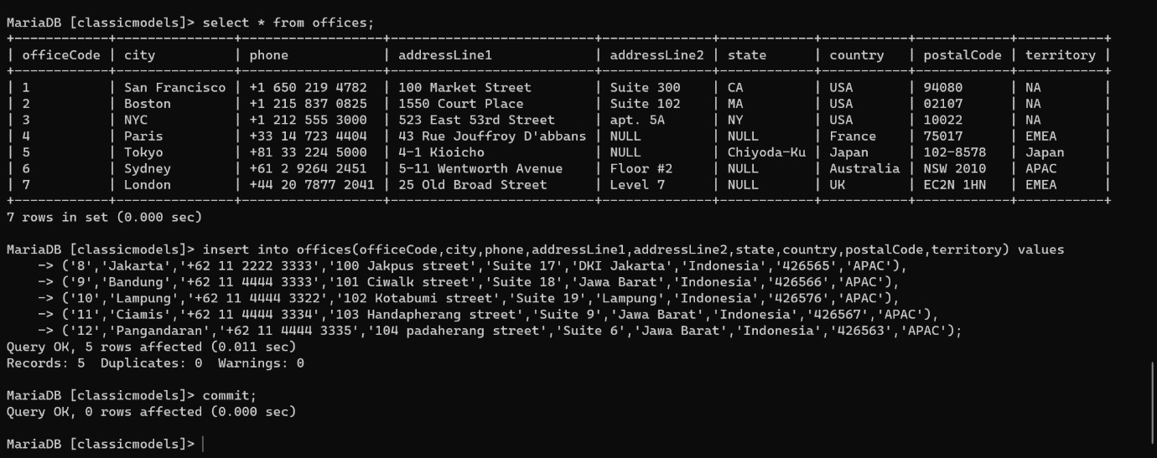

1. insert,udapte,delete lalu rollback insert into

offices(officeCode,city,phone,addressLine1,addressLine2,state,country,postalCode,territory) values

-> ('13','Jakarta','+62 11 2222 3333','100 Jakpus street','Suite 17','DKI Jakarta','Indonesia','426565','APAC');

update offices set city = 'Jakarta Selatan' where officeCode = '8'; delete from offices where city = 'Lampung';

rollback;

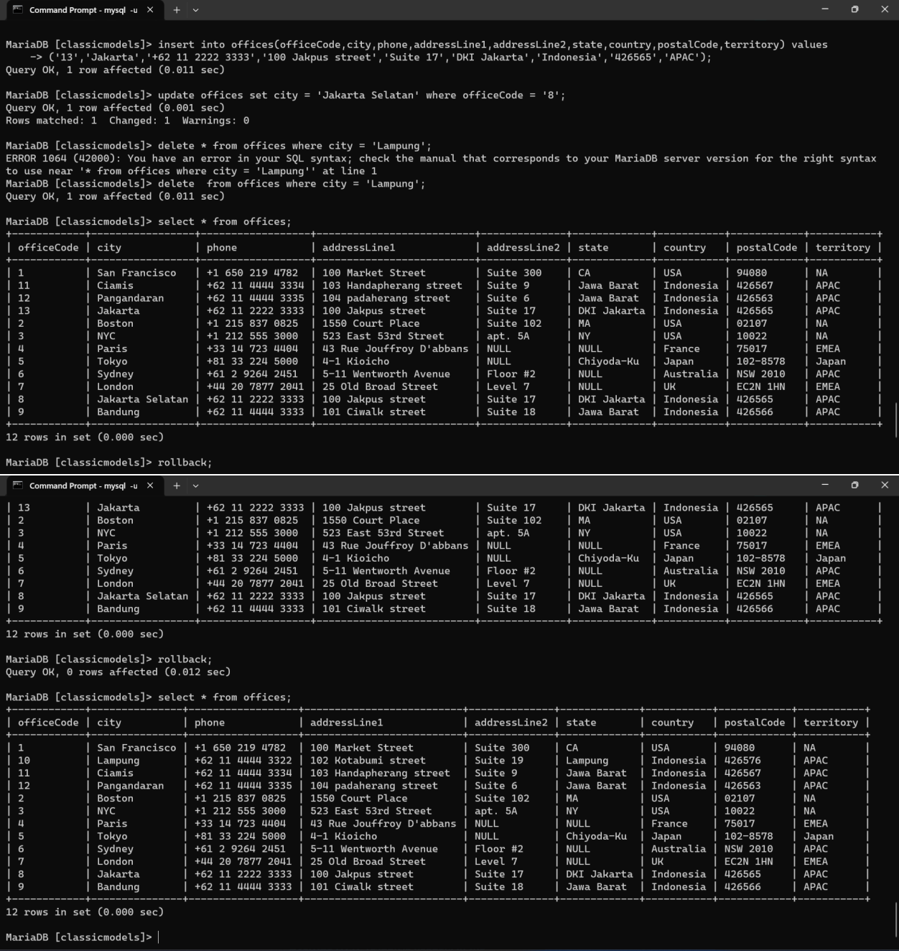

1. Create struktur table form gojek
   * create table customerGojek(id_cust int auto_increment primary key,nama_cust varchar(200),notelp_cust int(100));
   * create table driverGojek(id_driv int auto_increment primary key,nama_driv varchar(200),notelp_driv int(100),kendaraan varchar(200),platKen varchar(10));
   * create table orderGojek(id_orders int auto_increment primary key,id_cust int,id_driv int,tanggal_pesanan date,total_pay int,jenis_pay varchar (50),lokasi_awal varchar(200),lokasi_tujuan varchar(200),jarak varchar(20),waktu_perjalanan varchar(50), foreign key (id_cust) references customerGojek(id_cust), foreign key (id_driv) references driverGojek(id_driv));

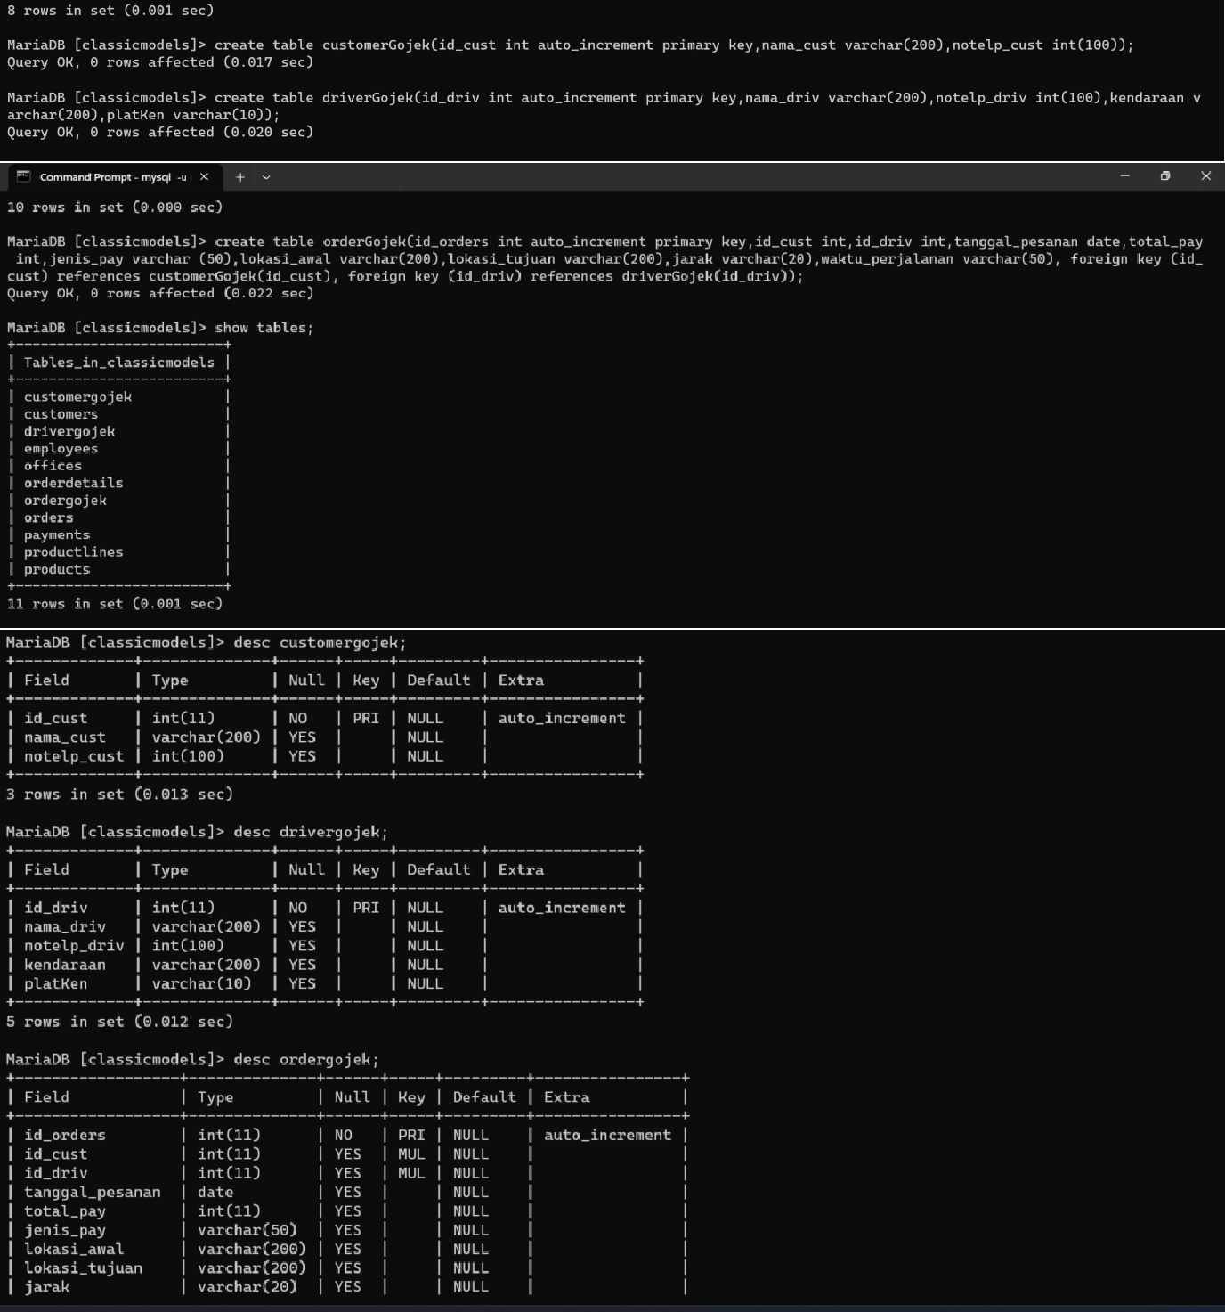

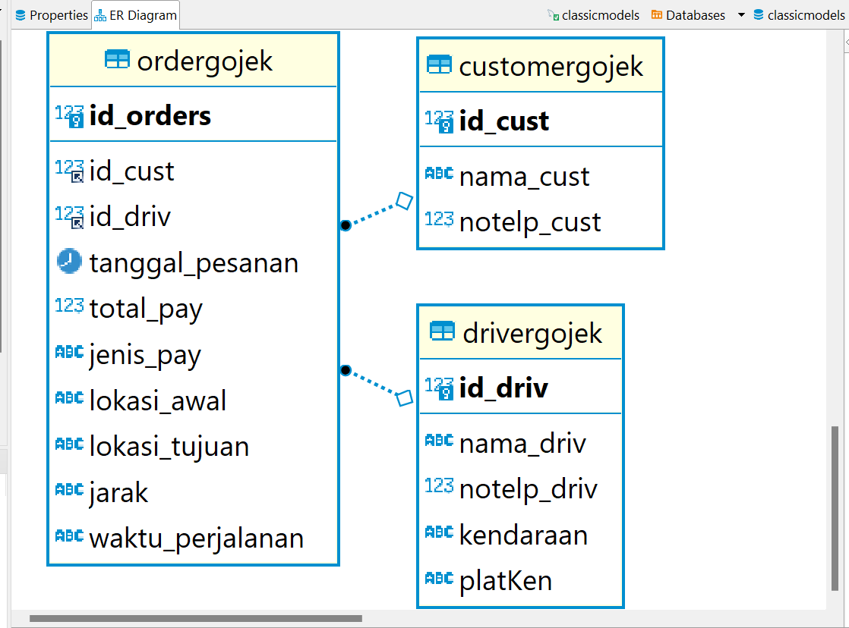

1. Insert query modul

insert into orderGojek(id_cust,id_driv,tanggal_pesanan,total_pay,jenis_pay,lokasi_awal,

-> lokasi_tujuan,jarak,waktu_perjalanan)

-> values ('1','2','2023-05-12','50000','Tunai','Bubat rgency a2 07 08 bandung jawabarat','jl h mansyur bojongsoang 120 bandung jawabarat','10km','50 Menit'),

-> ('1','3','2023-05-13','60000','Tunai','Aliaaea rgency a2 07 08 bandung jawabarat','jl h mansyur bojongsoang 120 bandung jawabarat','12km','60 Menit'),

-> ('2','1','2023-05-14','90000','Tunai','Aliaaea rgency a2 07 99 bogor jawabarat','jl h mansyur bojongsoang 120 bandung jawabarat','20km','80 Menit'),

-> ('3','4','2023-05-15','70000','Tunai','Aliaaea rgency a2 8887 99 bogor jawabarat','jl h mansyur bojongsoang 120 depok jawabarat','15km','70 Menit');

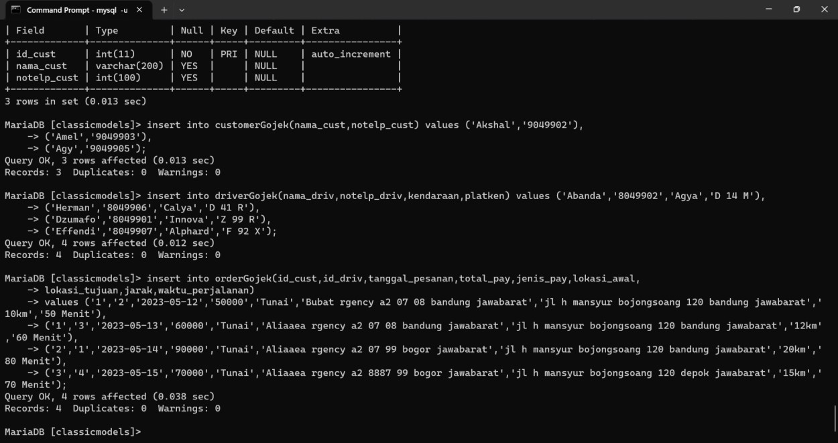

1. Select subquery modul

Select a.nama_cust,b.nama_driv,c.total_pay,c.jarak from ordergojek c join customergojek a on a.id_cust = c.id_cust join drivergojek b on b.id_driv = c.id_driv where c.total_pay in (select max(total_pay) from orderGojek);

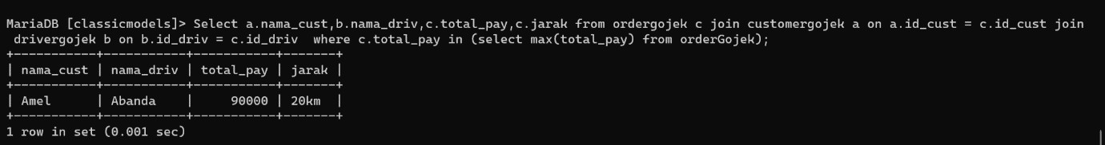

1. Update subquery

update drivergojek set nama_driv = 'Madanda' where id_driv in (select min(id_driv) from drivergojek);

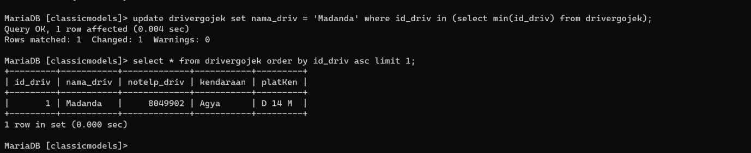

1. Delete subquery

delete from ordergojek where tanggal_pesanan in (select max(tanggal_pesanan) from ordergojek);

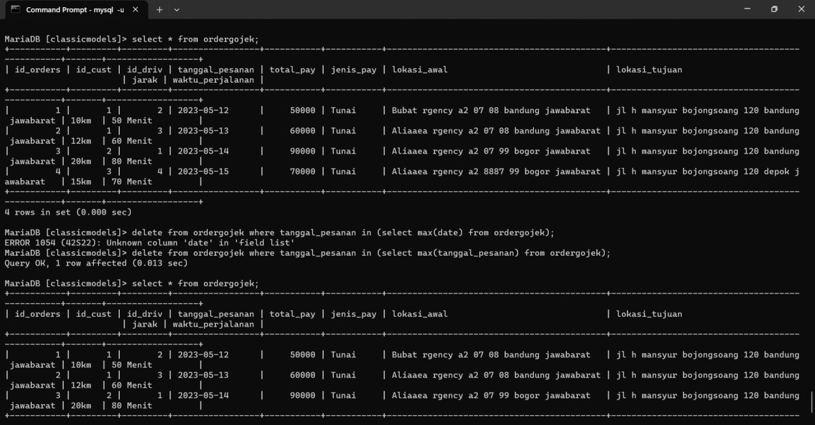

1. select dengan agresi terbesar

Select a.nama_cust,b.nama_driv,c.total_pay,c.jarak from ordergojek c join customergojek a on a.id_cust = c.id_cust join drivergojek b on b.id_driv = c.id_driv where c.total_pay in (select max(total_pay) from orderGojek);

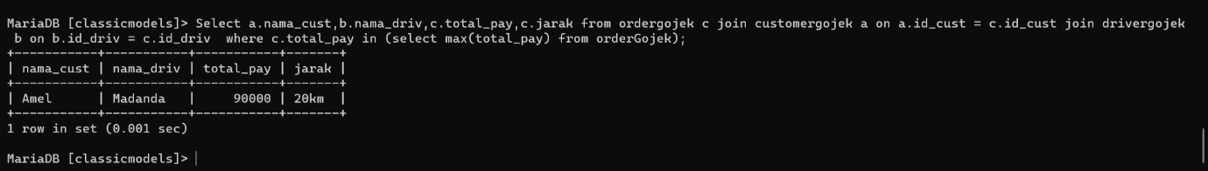

1. query dari subquery sebagai source Select

a.nama_cust,c.tanggal_pesanan,b.kendaraan,b.nama_driv,c.total_pay,c.lokasi_tujuan,c.jara k from ordergojek c join customergojek a on a.id_cust = c.id_cust join drivergojek b on b.id_driv = c.id_driv where c.tanggal_pesanan in (select max(tanggal_pesanan) from orderGojek);

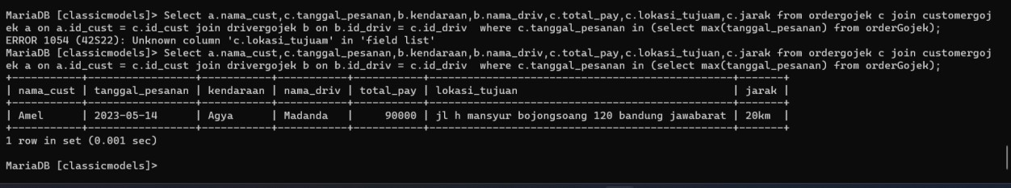

1. combine union Select

a.nama_cust,c.tanggal_pesanan,b.kendaraan,b.nama_driv,c.total_pay,c.lokasi_tujuan,c.jara k from ordergojek c join customergojek a on a.id_cust = c.id_cust join drivergojek b on b.id_driv = c.id_driv where c.tanggal_pesanan in (select max(tanggal_pesanan) from orderGojek)

union Select

a.nama_cust,c.tanggal_pesanan,b.kendaraan,b.nama_driv,c.total_pay,c.lokasi_tujuan,c.jara k from ordergojek c join customergojek a on a.id_cust = c.id_cust join drivergojek b on b.id_driv = c.id_driv where c.tanggal_pesanan in (select min(tanggal_pesanan) from orderGojek);

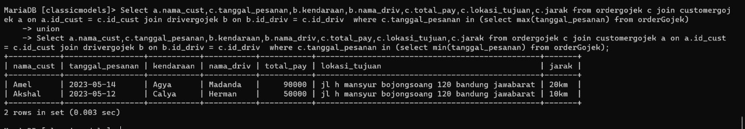

1. combine intersect Select

a.nama_cust,c.tanggal_pesanan,b.kendaraan,b.nama_driv,c.total_pay,c.lokasi_tujuan,c.jara k from ordergojek c join customergojek a on a.id_cust = c.id_cust join drivergojek b on b.id_driv = c.id_driv where c.total_pay in (select max(total_pay) from orderGojek)

-> intersect

-> Select a.nama_cust,c.tanggal_pesanan,b.kendaraan,b.nama_driv,c.total_pay,c.lokasi_tujuan,c.jara k from ordergojek c join customergojek a on a.id_cust = c.id_cust join drivergojek b on b.id_driv = c.id_driv where c.id_cust = 2;

